1. For DJs on Demand, display the number of months between the event_date of the Vigil wedding and today’s date. Round to the nearest month.
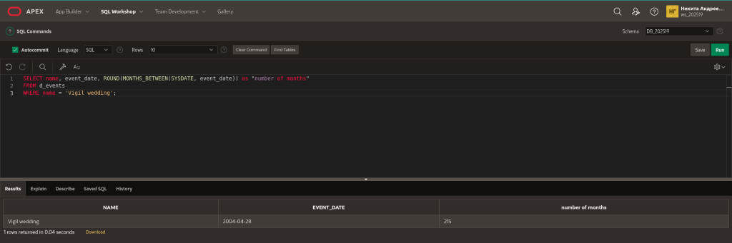
2. Display the days between the start of last summer’s school vacation break and the day school started this year. Assume 30.5 days per month. Name the output “Days.”
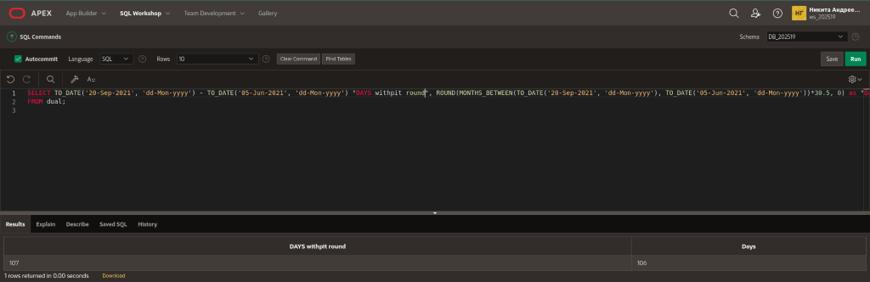
3. Display the days between January 1 and December 31.
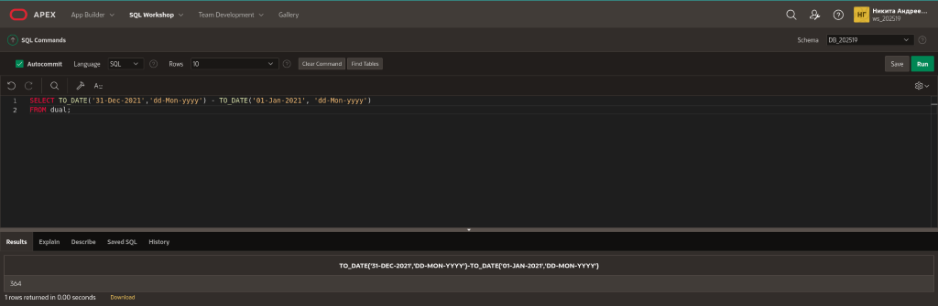
4. Using one statement, round today's date to the nearest month and nearest year, and truncate it to the nearest month and nearest year. Use an alias for each column.
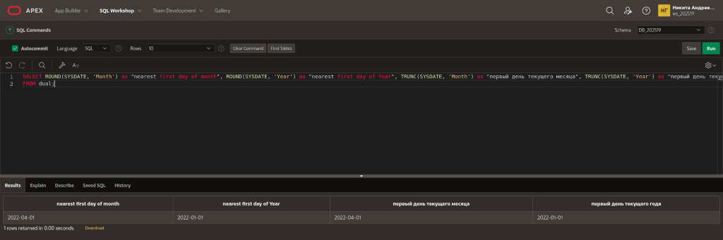
5. What is the last day of the month for June 2005? Use an alias for the output.
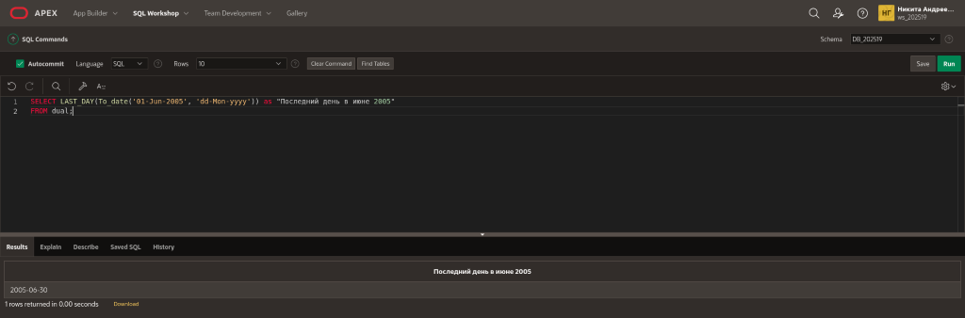
6. Display the number of years between the Global Fast Foods employee Bob Miller’s birthday and today. Round to the nearest year.
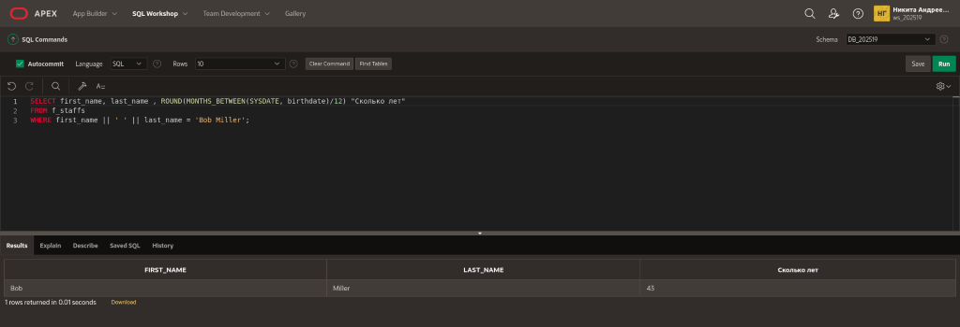
7. Your next appointment with the dentist is six months from today. On what day will you go to the dentist? Name the output, “Appointment.”
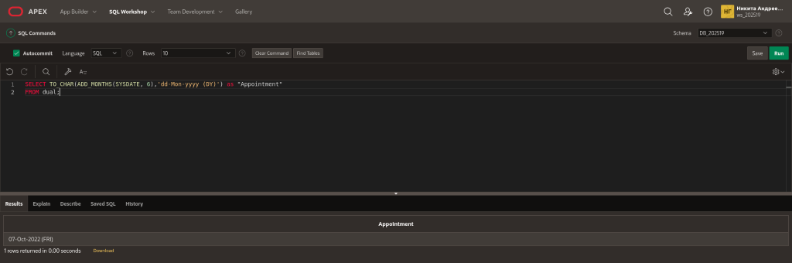
8. The teacher said you have until the last day of this month to turn in your research paper. What day will this be? Name the output, “Deadline.”
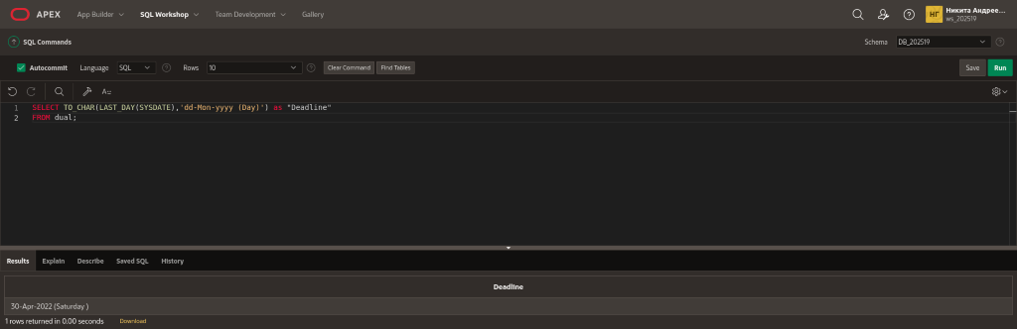
9. How many months between your birthday this year and January 1 next year?
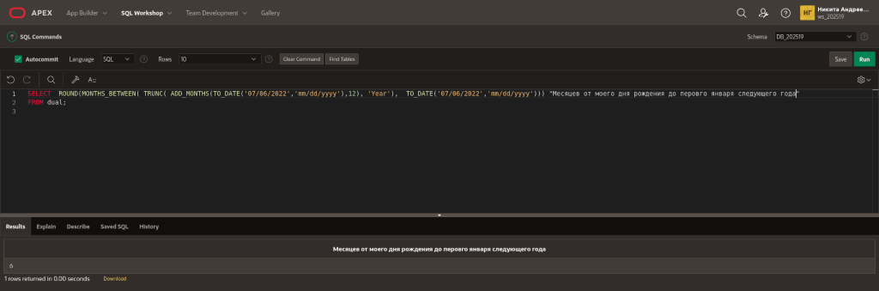
10.What’s the date of the next Friday after your birthday this year? Name the output, “First Friday.”

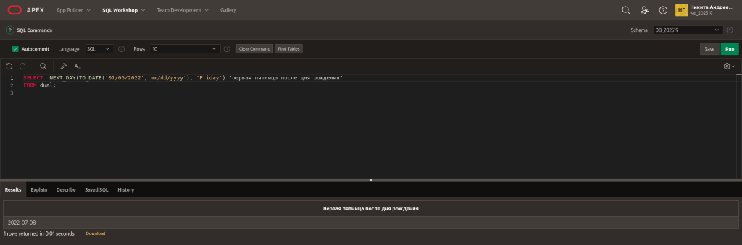
11.Name a date function that will return a number.
MONTHS_BETWEEN
12.Name a date function that will return a date.
ADD_MONTHS
13.Give one example of why it is important for businesses to be able to manipulate date data?
В любой организации всегда важно уметь считать даты. Например, в работе кадровиков важно уметь правильно считать отпускные дни, следить за государственными праздниками и поздравлять коллег с днем рождения.

1. Using DUAL, write a statement that will convert 86.678 to 86.68.
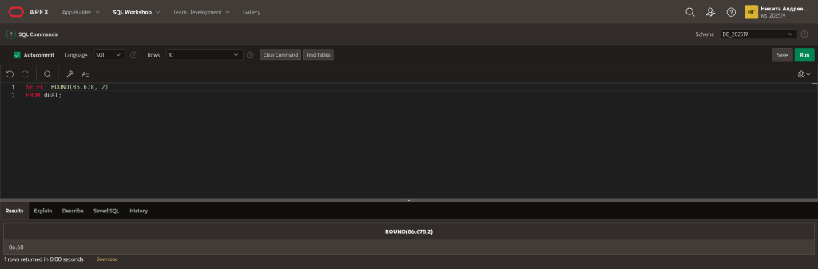
2. Write a statement that will display the DJs on Demand CD titles for cd_numbers 90 and 91 in uppercase in a column headed “DJs on Demand Collections.”
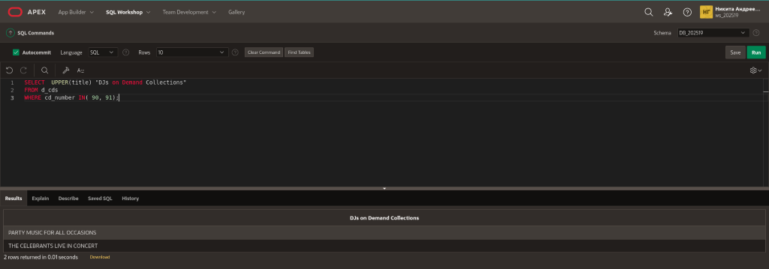
3. Write a statement that will create computer usernames for the DJs on Demand partners. The usernames will be the lowercase letters of the last name + the uppercase first letter in the first name. Title the column “User Passwords.” For example, Mary Smythers would be smythersM.
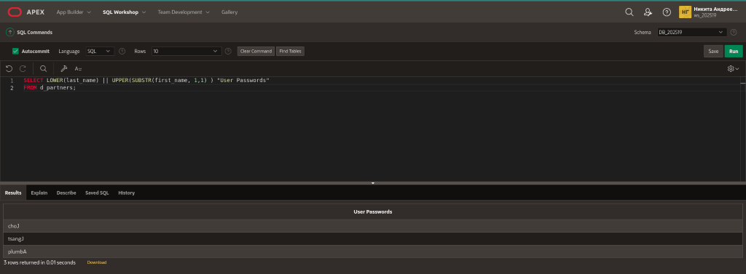
4. Write a statement that will convert “It’s a small world” to “HELLO WORLD.”
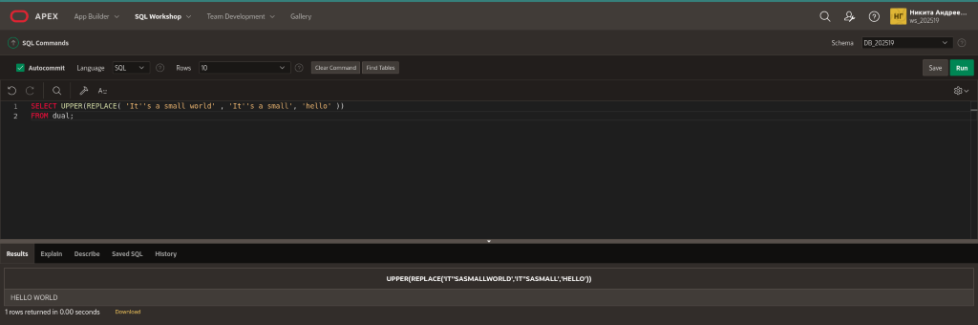
5. Write a statement that will remove the “fiddle” from “fiddledeedee” and the “dum” from “fiddledeedum.” Display the result “fiddledeedeedee” in a column with the heading “Nonsense.”
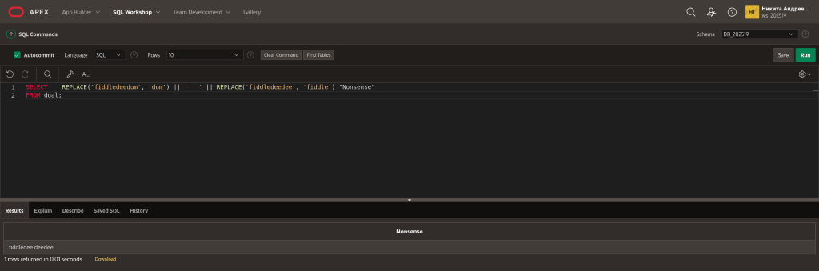
6. Replace every “i” in Mississippi with “$.”
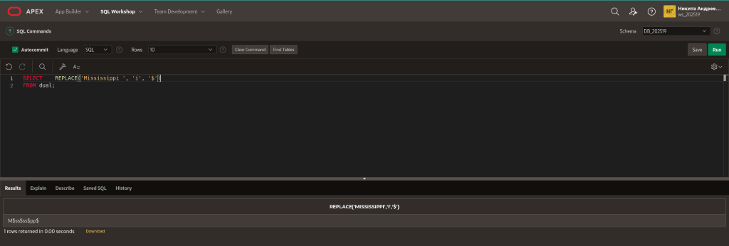
7. Using DUAL, convert 5332.342 to 5300.
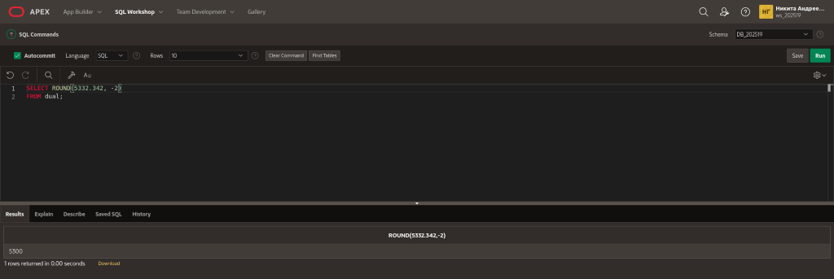
8. Using DUAL, convert 3.14159 to 3.14.
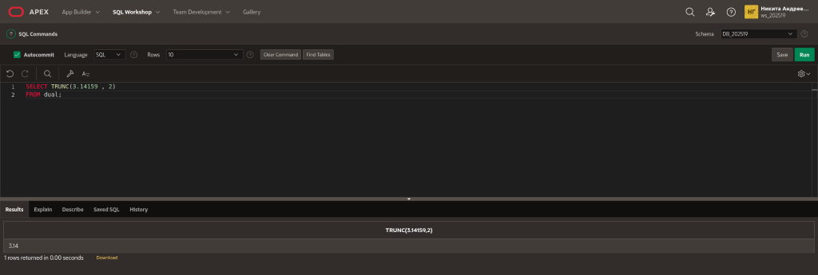
9. Using DUAL, convert 73.892 to 73.8.
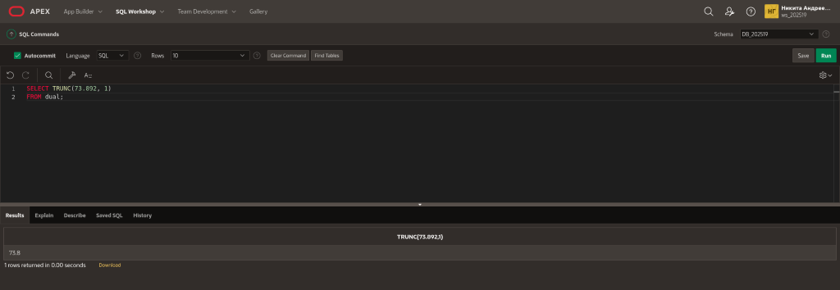
10.What is the next Friday six months from now? Label the column “Future.”
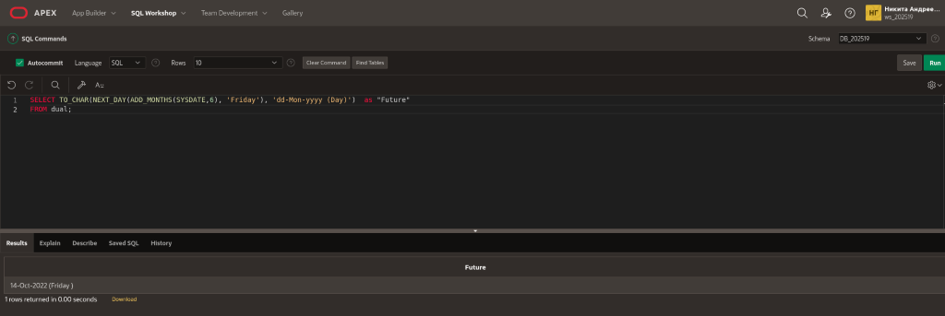
11.What is the date 10 years from now? Label the column “Future.”
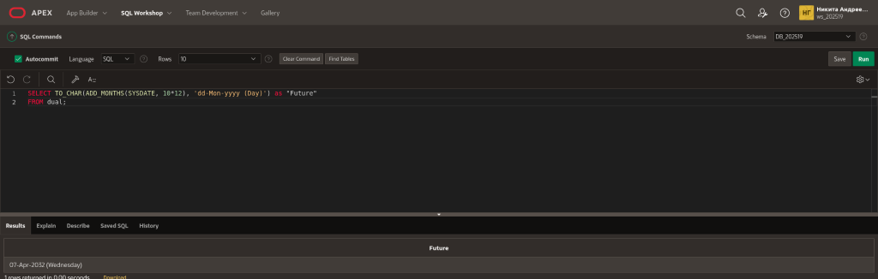
12.Leap years occur every four years. Remember, 2004 was a leap year. Now create a function that will show the date of the next leap year as 29-Feb-2008. Label the column “Future.”
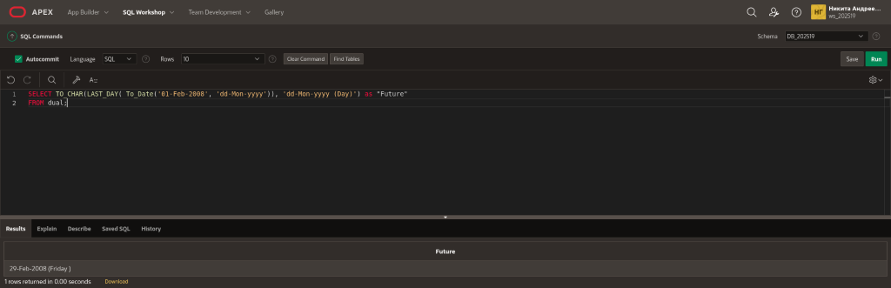
13.Write a statement that will find any of the DJs on Demand CD themes that have an “ie” in their names.
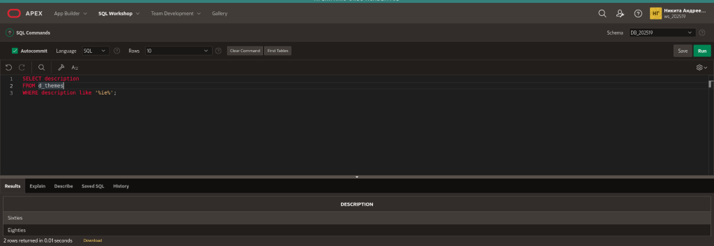
14.Write a statement that will return only the DJs on Demand CDs with years greater than 2000 but less than 2003. Display both the title and year.
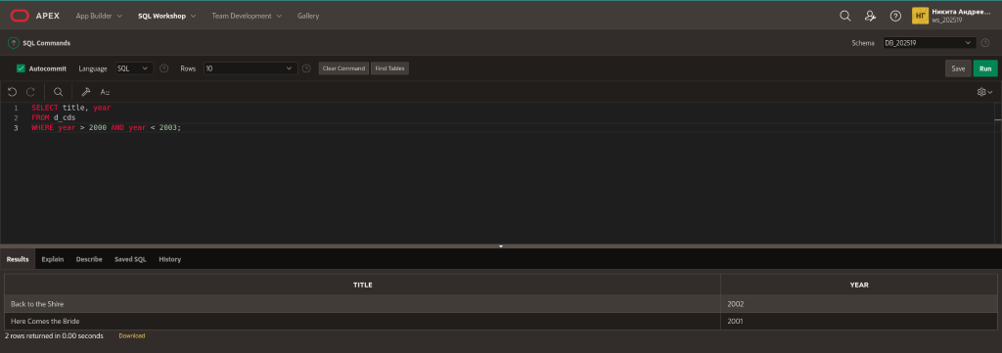
15.Write a statement that will return the Oracle database employee’s employee ID and his starting hire dates between January 1, 1997 and today. Display the result ordered from most recently hired to the oldest.

